**ANN Model Modifier technique -Knowledge Transfer for Zig-Zag Energy Harvester:**

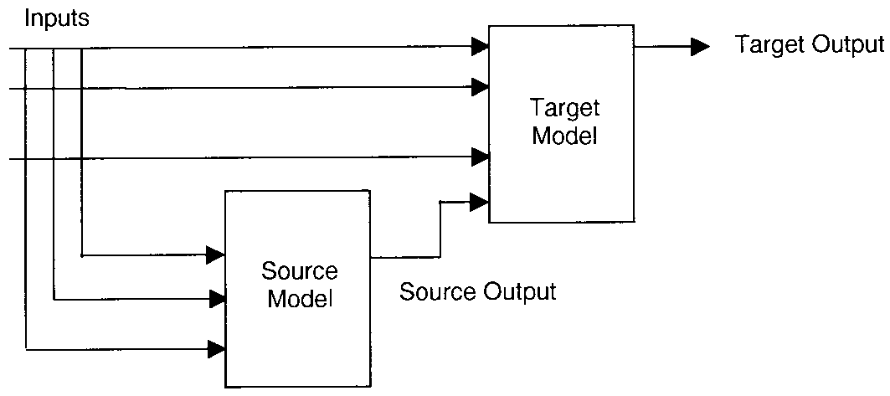

**Knowledge transfer in a nutshell: Guessing another parameter from known parameter which can be expressed as its function.**

|  |  |  |
| --- | --- | --- |
| Number of Neurons | Relative Error (%) (without knowledge transfer) | Relative error (%) (with knowledge transfer) |
| 2 | 2.27 | 1.5 |
| 4 | 1.74 | 1.3 |
| 6 | 1.21 | 1.2 |
| 8 | 1.02 | 1.2 |
| 10 | 1.06 | 1.2 |

**Results of the Neural Network Model for Elephant Harvester:**

**Energy Harvester:**

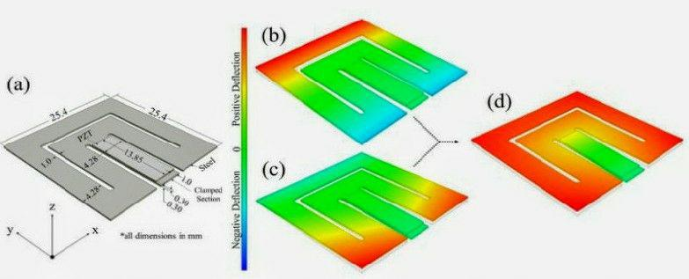

**RELATIVE ERROR:**

|  |  |  |
| --- | --- | --- |
| **Mass (vs)** | **RMSE** | **Relative Error (%)** |
| F1 | 0.582 | 0.545 |
| F2 | 1.45 | 0.993 |
| P1 | 0.78 | 5.75 |
| P2 | 1.12 | 8.11 |

**Neural Network Prediction for F1 (vs) F2 :**

**Neural Network Prediction for P1 & P2:**

**Number of Neurons**